God Loves You!



**Haverhill Methodist Church**

Revd. Moses John

Superintendent Minister

T: 07881 114293

E: moses.john@methodist.org.uk

HMC Senior Steward

Claire Waller

T: 07825 277542

E: wallerclaire@sky.com

Rev. Peter Goodhall

The Manse

24 Hamlet Road

Haverhill

Suffolk

CB9 8EH

T: 01440 702422

E: [methodistpeter@gmail.com](mailto:methodistpeter@gmail.com)

ev. Peter Goodhall

The Manse

24 Hamlet Road

Haverhill

Suffolk

CB9 8EH

T: 01440 702422

E: [methodistpeter@gmail.com](mailto:methodistpeter@gmail.com)

ev. Peter Goodhall

The Manse

24 Hamlet Road

Haverhill

Suffolk

CB9 8EH

T: 01440 702422

E: [methodistpeter@gmail.com](mailto:methodistpeter@gmail.com)



**Connect Issue 271** **Friday 15th August 2025**

*But those who hope in the Lord will renew their strength. They will soar on wings like eagles; they will run and not grow weary, they will walk and not be faint.*

*Isaiah 40:31*

**Prayer Chain:** If you’d like to request a prayer for yourself, or for someone you know, please email [kathy.cohen@btinternet.com](mailto:kathy.cohen@btinternet.com) (or phone 01440 762536) and your message will be forwarded to all those on the prayer email list (about 200 people).

## Prayer Ministry: This is available after the morning service each Sunday. Please approach someone wearing a lime green lanyard which has the words Prayer Ministry Team printed on it.

Please remember our Churches Together online Prayer Wall [here](https://bit.ly/4dec2PT)

**Hearing Loop:** We have a hearing loop, switch your hearing aid to the T position if available.

**Mobile Phones:** Please make sure your phone is off or set to silent before the service begins.

* Refreshments after the service

I am in the process of typing a new rota for helpers on Sunday morning. If you would like to be included, please speak either to me or one of the Stewards. We need two people each Sunday and you would be paired with someone who has experience in our kitchen. It is a great way to get to know new people and a blessing to us all.

Thanks, Joyce Rinaldi

* Book Sale

There are a few ‘old stock’ books available, from Next Door’s bookshop on the table in the Church foyer. Please have a browse and take any you

would like then, if you are able, leave a small donation in the basket.

* Church Family BBQ

On Sunday 7th September we will be celebrating the Sunday School Anniversary recognising our wonderful children and young people. Following the service we will be hosting a BBQ for the whole church family. We would love all of you to join us. There is a sign up sheet in the front foyer of the church. Please do sign up as we will need to know numbers for shopping. Please also note on the sign up sheet any specific dietary requirements.

We are in need of gas BBQs, (we probably will need 4/5), if this is something you can help us with then please do let myself or one of the catering team know asap.

Important announcement - the car park will be out of action that day as we will be hosting the BBQ in the car park.

Many thanks

Susan Marren

* Methodist Prayer Handbook 2025/26

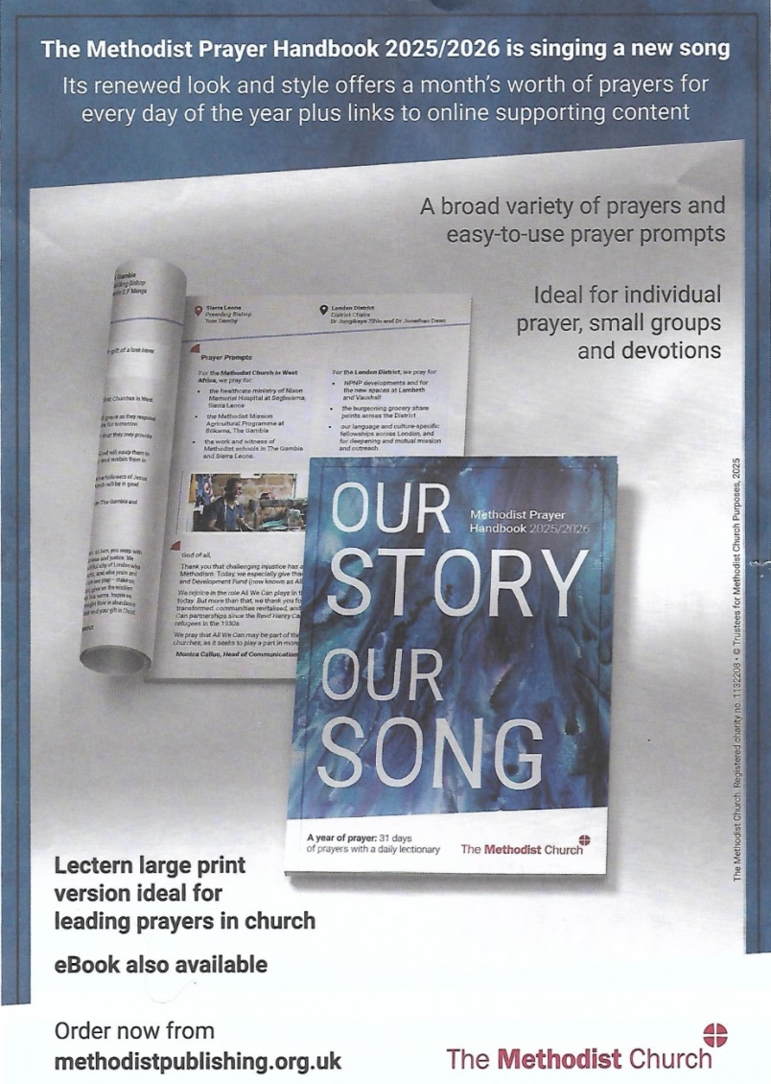

The Prayer Handbook for the forthcoming Methodist year is now available.

Ken Nicholls will be ordering some in bulk at a slightly reduced price, please speak to Ken to reserve your copy.

* Ride & Stride

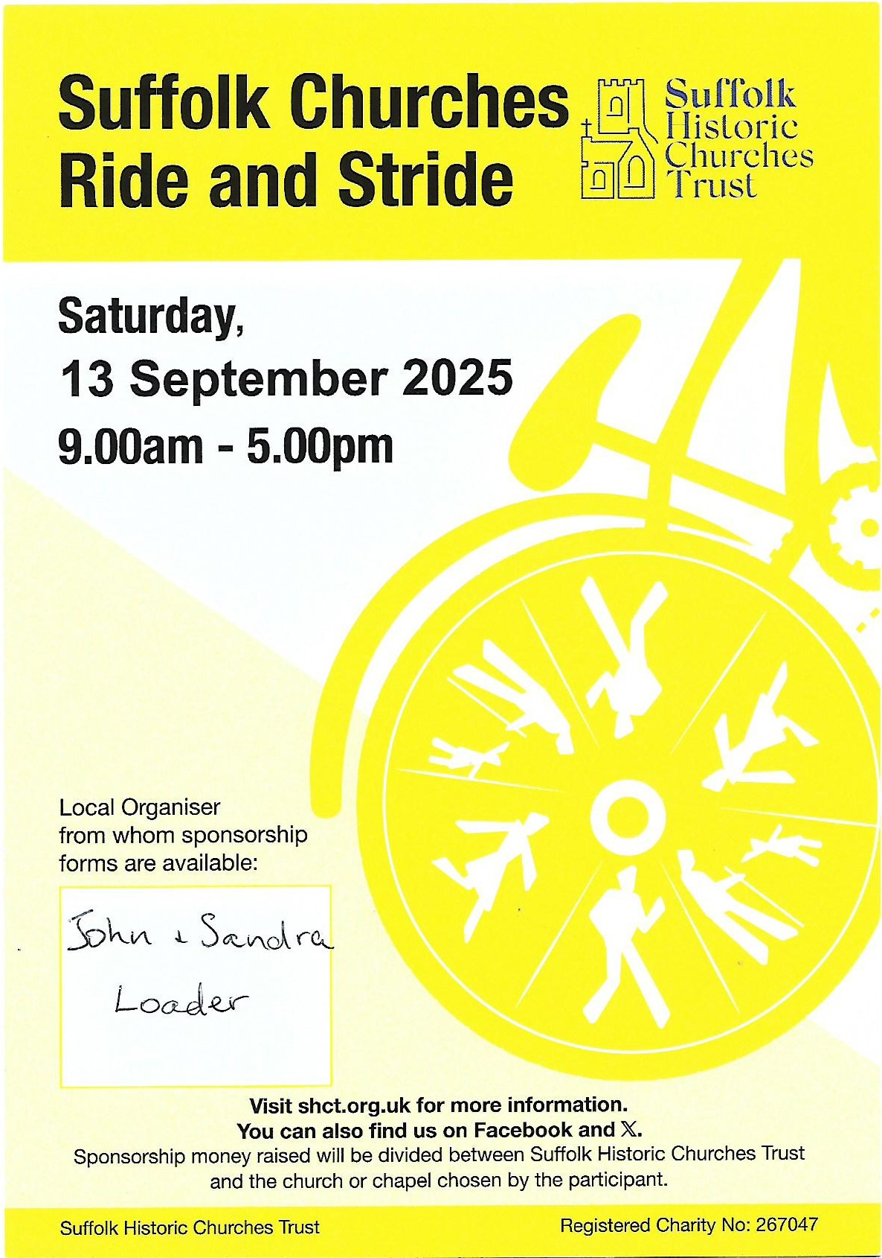

Speak to Sandra or John to get your sponsor form or if you don’t fancy doing the leg work, find someone who is and sponsor them!

Half the money we raise comes back to this church.

We will also be looking for people to be at church to welcome visitors on the day – and you can be sponsored for how many you greet too!!

* Global Week of Prayer

**1st to 7th September 2025**

Join in for the 30-minute themed prayer times on Monday to Friday - 7am, 1pm and 7pm.

Also available are hour long slots for personal prayer throughout the week, including the non-stop prayer relay on Friday and Saturday.

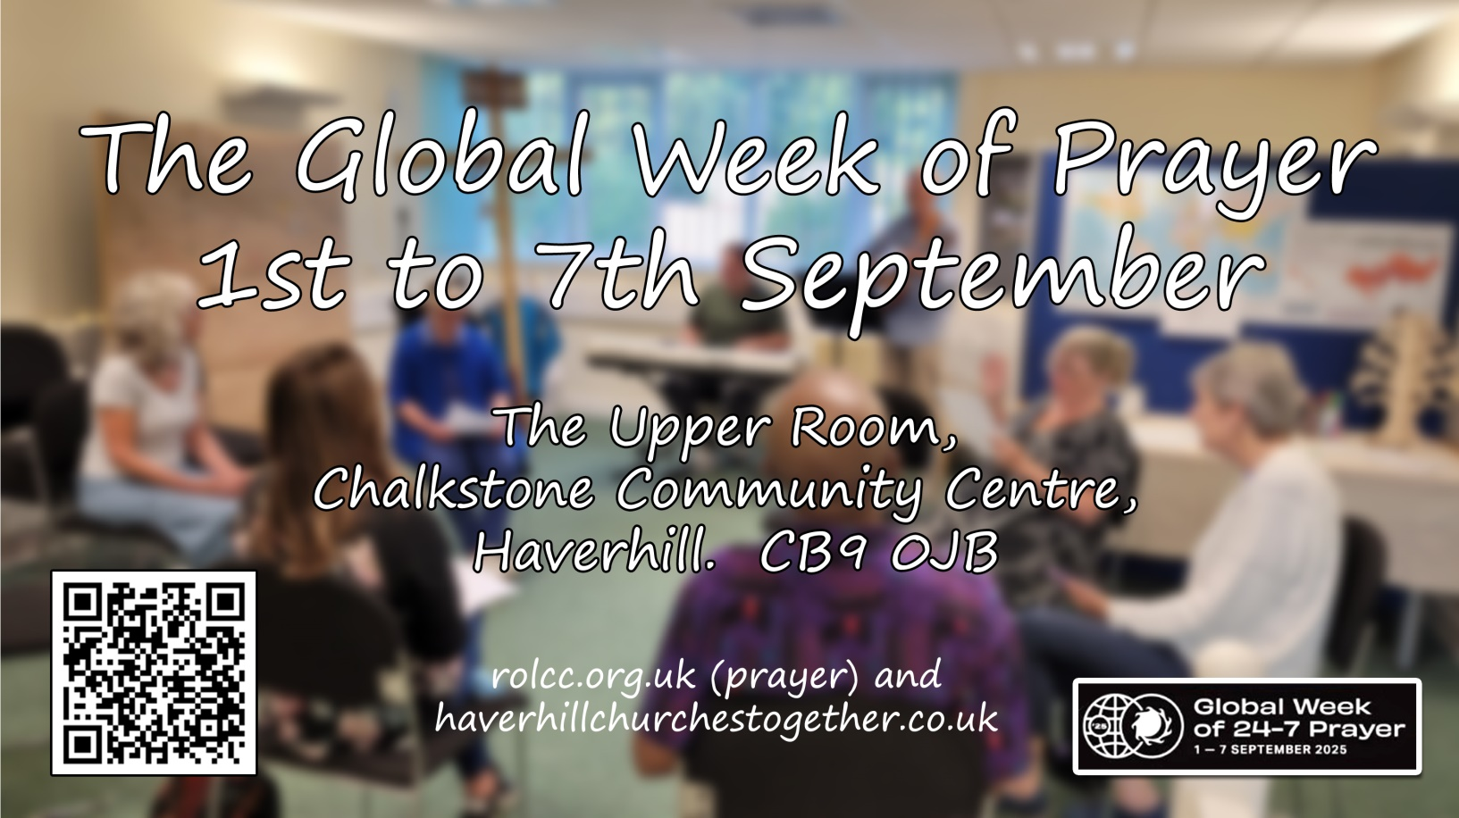

Book your slot via the QR code below or the website at <https://signup.24-7prayer.com/signup/47306d>

There are more details too on <https://www.rolcc.org.uk/Groups/448011/River_of_Life/Church_Life/Prayer/Week_of_Global/Week_of_Global.aspx> and [www.haverhillchurchestogether.co.uk](http://www.haverhillchurchestogether.co.uk)

Any questions, please get in touch with Angela or Henry Wilson on 07710 618951

Email - [Henry.wilson@rolcc.org.uk](mailto:Henry.wilson@rolcc.org.uk)



* Sizewell 50th Anniversary

This year marks the 50th anniversary of Sizewell Hall. A celebration service will be held on 7th September in the evening with Victor Jack speaking.

Full details in the poster below.

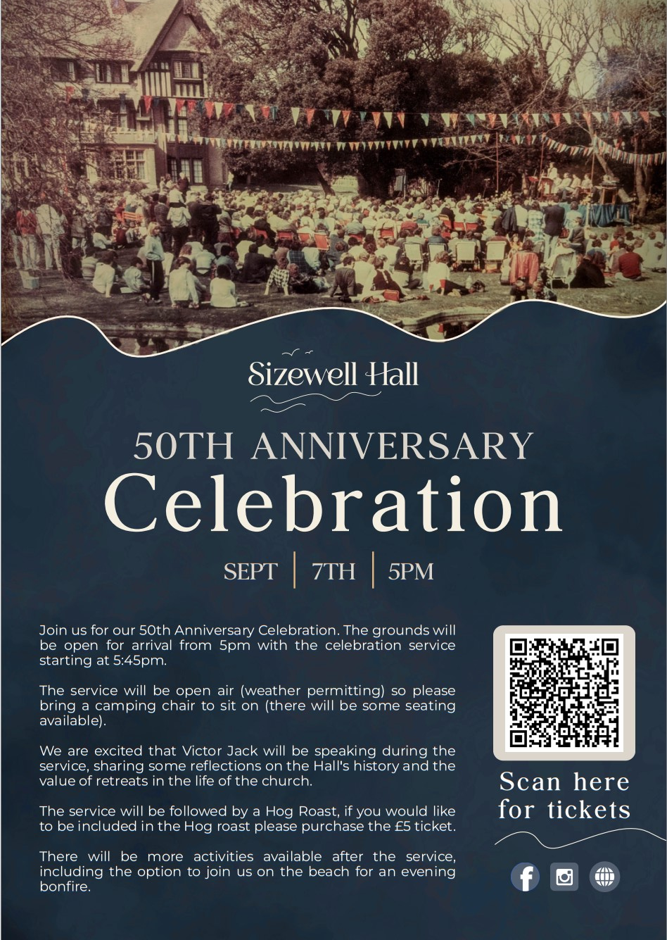

QR code goes to <http://bit.ly/4mBwwX0>

* Events at Thetford

There are three events upcoming at The Hub, Liberty Church,Thetford to which we have been invited.

* Flourish Women’s Conference – Saturday 27th September 11.30-4pm

Lunch included £12

* Elemental Men’s Evening Gathering – Saturday October 11th 6.15-8.45pm Supper included £5
* HubYouth An Evening Gathering for Church Youth – Saturday November 22nd 6.30-8,30pm and it’s free

Full details can be found on the flyers at the end of this edition of Connect.

* ‘Here Am I, Lord’ - an inter-denominational foundation course in evangelism.



In brief: the course is free and runs on the Zoom platform on the dates shown on the poster above. The aim of the course is to build confidence in the Lord for the ministry of evangelism, for which we believe there is an ever-increasing need. Anyone interested should come through the appropriate church leadership.

Steve Norris

A leaflet with a more detailed breakdown of the course is available in the church foyer.

* Grapevine

The theme of the next edition of Grapevine magazine will be 'Our Story'. We have chosen this theme to fit with the Conference theme and what we are currently sharing across Connexion.

To provide a little bit of inspiration here is a link to a video of the new President & Vice President of Conference sharing their stories.

[Introducing our new President and Vice-President - The Methodist Church](https://www.methodist.org.uk/for-churches/resources/videos/introducing-our-new-president-and-vice-president/)

We would really like to share your story!

Wwe are inviting churches and individuals to tell us 'your story'. This could be the story of your church, of you as an individual, maybe how you came to be a methodist, or doing the role that you do, or the story of the group that you are a part of or a project that you support.

If you would like to contribute an article on this theme, I would be grateful if you could let me know.  Articles should be around 400 – 500 words and photos may be included (sent separately from the text). The deadline for articles is Wednesday 3rd September but it would be great to receive them before then!

We really appreciate all the contributions we receive, and I shall look forward to hearing from you.

Many thanks and kind regards

Ms Danielle Gravestock

District Administrator

District Office, Chapel Field Road Methodist Church, Norwich, NR2 1SD

Tel: 01603 625765            Email: office@eangliamethodist.org.uk

* Town Pastors



The Town Pastors will be on the streets next Friday 22nd August, from 8pm to midnight. Please keep them in your prayers and support those who bring this important ministry to our streets.

If you are interested in becoming part of this aspect of God’s work in our town please speak to Kathy, Angela Proctor, David Payne, Phoebe, Mary Thake, Pat Shanks, Dot Parker, Sarah Glasswell, Paula Tappin or Jack Tappin, we can all tell you about our experiences as home prayers, base leaders or actually being out on the streets. Or contact the chairman, Ian Levett.

* Car Park

To help relieve congestion in the church car park on Sunday mornings we have been given kind permission by the Haverhill Family Practice doctors’ surgery and pharmacy to use their rear car park. This is located just down Camps Road from the church (NOT the one across the road).

Please take care and be considerate to other users, from the Baptist Church and Haverhill Pharmacy, or else this kind privilege could be withdrawn. ***Parking at any time other than Sunday mornings is prohibited.***

* Weekly Offering & Gift Aid

We do not ask visitors for money, however should you wish to give there is an offering bowl just inside the main doors to the church at each service.

If you wish to give regularly by standing order/online banking (which helps us avoid banking costs incurred by paying in cash/cheques) the account details are as follows.

Account name: Haverhill Methodist Church.

Account number: 00060578 Sort code: 30-93-99.

You can also help without increasing your current giving: if you already have a standing order and pay tax to the Inland Revenue, you can sign the Gift Aid declaration, which will boost your donation by 25%. The Gift Aid Declaration form can be requested from any steward. The amount claimed back in recent years has approached £10,000 pa and has often prevented expenditure exceeding income in the annual accounts.

* Haverhill & District Churches Together News and Events

Dates of Haverhill Praise at West End Congregational Church, all at 4pm:  
 Sep 28th, Nov 30th

* Town Centre Survey

If you are interested in the future of our town centre and would like to put your views forward, there is a short survey you can complete at <https://orlo.uk/fim41>

* Service for the anniversary of VJ Day

Flag raising ceremony on the Market Square, 9am Friday 15th August,

Service of Commemoration, Thursday 21st August, 7pm @ St Mary’s.

Lots more info at: <https://haverhill-tc.gov.uk/vj-day-80/>

*Information for publication in Connect, or on the Sunday Morning Scroll may be emailed to:* [*kathy.cohen@btinternet.com*](mailto:kathy.cohen@btinternet.com)

Dates for your Diary

|  |  |  |
| --- | --- | --- |
| **August** |  |  |
| 17th | 10.30am | Preacher: Rev Moses John- Communion  Prayer time 10am in Coffee Lounge  Flowers: Sylvia and Mike Webb |
| 19th | 11am-12 | Tuesday Prayer in Coffee Lounge (or in your own home) |
| 20th | 10am-12 | Open Mind in the Church Hall |
| 24th | 10.30am | Preacher: Rev Moses John  Prayer time 10am in Coffee Lounge  Flowers: Mary Thake & Ann Turner |
| 26th | 11am-12 | Tuesday Prayer in Coffee Lounge (or in your own home) |
| 27th | 10am-12 | Open Mind in the Church Hall |
| 30th | All day | Haverhill Show - Take 2 |
| 31st | 10.30am | Preacher: Kim Moses Flowers: Linda Arrowsmith  Prayer time 10am in Coffee Lounge |
| **September** |  |  |
| 2nd | 11am-12 | Tuesday Prayer in Coffee Lounge (or in your own home) |
| 3rd | 10am-12 | Open Mind in the Church Hall |
| 7th | 10.30am | Sunday Club Anniversary service followed by Barbeque for all the Church Family – Please sign up so we can have enough food!  NO PARKING in Church Car Park today!  Prayer time 10am in Coffee Lounge Flowers: Vacant |
| 9th | 11am-12 | Tuesday Prayer in Coffee Lounge (or in your own home) |
| 10th | 10am-12 | Open Mind in the Church Hall |
|  | 1-3pm | Young at Heart in the Church Hall |
| 14th | 10.30am | Preacher: Rev Moses John- Communion  Prayer time 10am in Coffee Lounge Flowers: Phyl Hall |
| 16th | 11am-12 | Tuesday Prayer in Coffee Lounge (or in your own home) |
| 17th | 10am-12 | Open Mind in the Church Hall |
|  | 1-3pm | Young at Heart in the Church Hall |
| 21st | 10.30am | Preacher: Rev Moses John – Membership Service  Prayer time 10am in Coffee Lounge  Flowers: Anthea & David Payne |
| 23rd | 11am-12 | Tuesday Prayer in Coffee Lounge (or in your own home) |
| 24th | 10am-12 | Open Mind in the Church Hall |
|  | 1-3pm | Young at Heart in the Church Hall |
| 28th | 10.30am | Preacher: Sarah Glasswell  Prayer time 10am in Coffee Lounge Flowers: Vacant |

*\* If you would like to join the Flower Rota, please contact Sue Symonds*

*01440 763613 or* [*harrys62@sky.com*](mailto:harrys62@sky.com)

**

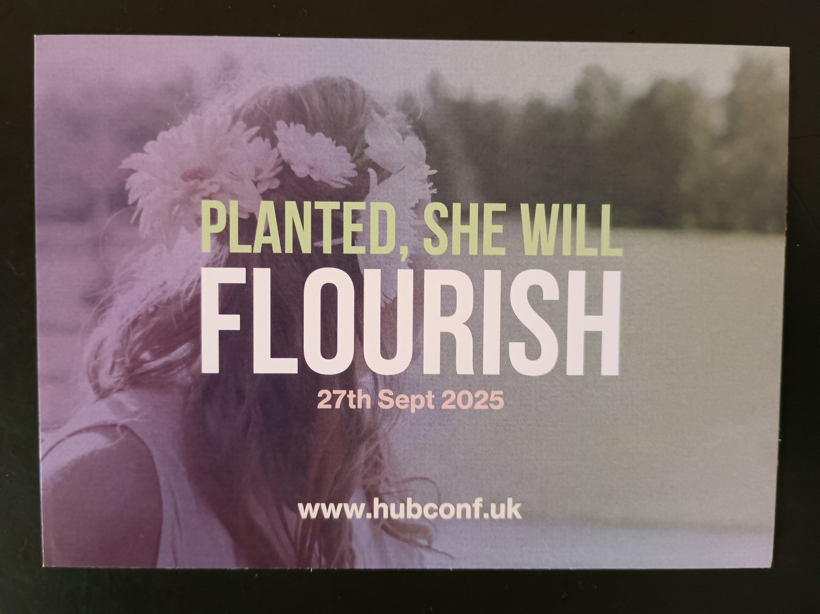

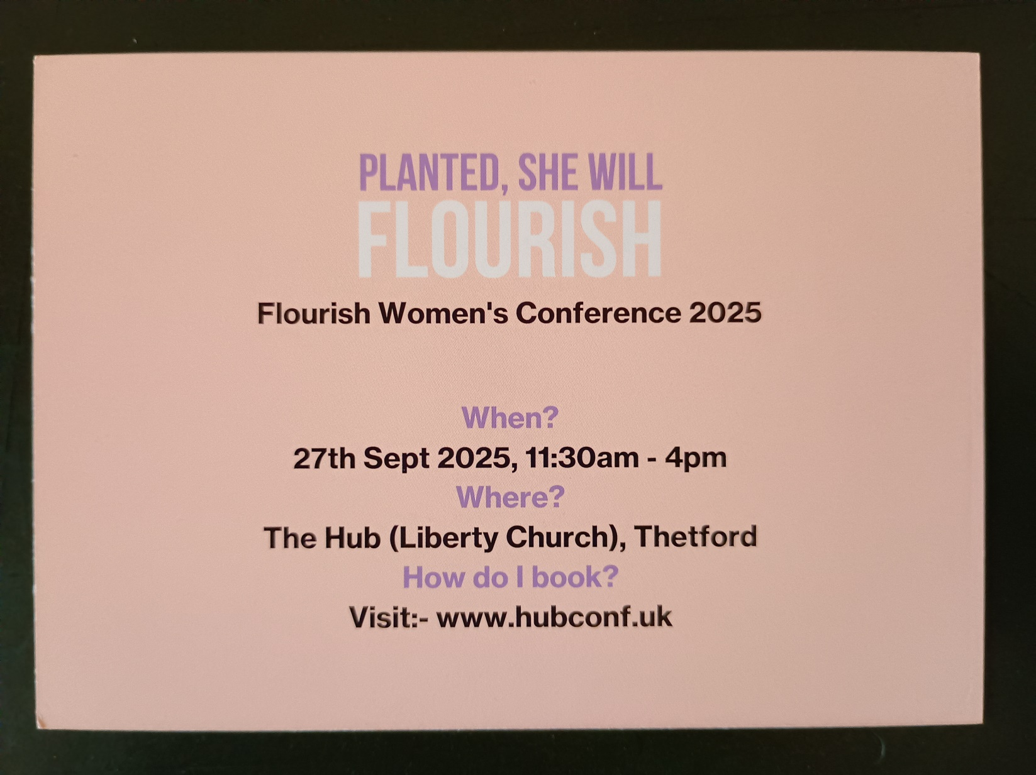







Complete information available here: [www.hubconf.uk](http://www.hubconf.uk)